Core competences for children
and young people aged 5-16 years:

A framework of skills and knowledge around food,
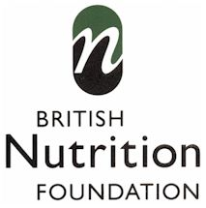
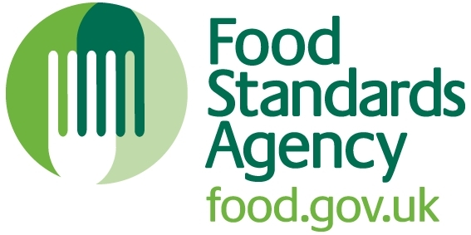
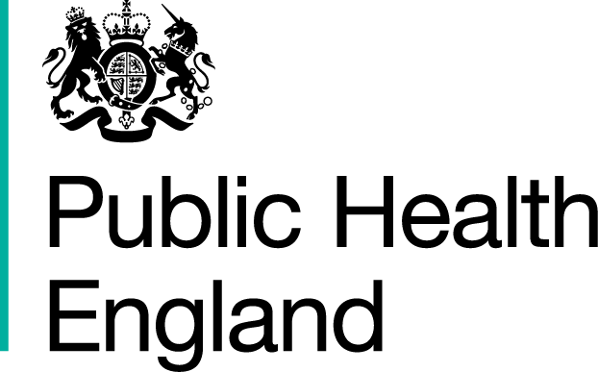
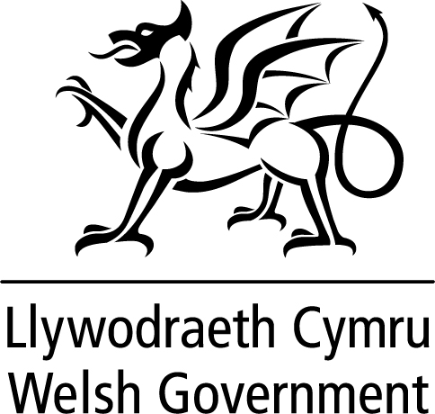
diet and physical activity
      

Acknowledgments
In 2007, the Food Standards Agency (FSA) launched Core Food Competences for children aged 5-16 years, developed in consultation with the British Nutrition Foundation (BNF). The competences set out a progressive framework of skills and knowledge which comprise essential building blocks around the themes of diet and health, consumer awareness, cooking and food safety for children and young people. These competences have been widely used, as they provided consistency and a focal point. Uses included an audit tool for teachers mapping out lessons, a guide for developers creating resources for schools and a framework to support curricular change and examination specifications.

Since the original launch of the competences, there have been changes in the curricula around the UK, new education initiatives and policy. It is therefore important that these competences are still fit-for-purpose to fully support teachers and learners.

BNF, along with Public Health England (PHE), FSA Northern Ireland, FSA Scotland and the Welsh Government, initiated a review of the original framework to ensure that it is up-to-date and reflects key areas of priority for children and young people in relation to their education, life skills and health. The updated framework, which includes changes in light of a consultation in January 2014, is now published. The competences now include physical activity, as well as an enhanced consumer awareness section. An additional review was carried out in 2016 following the launch of the new UK Healthy Eating Model – the Eatwell Guide.
Core competences for children and young people aged 5-16 years
- The competences represent core skills and knowledge around the themes of Diet (food and drink), Consumer Awareness, Cooking (Food Preparation and Handling skills), Food Safety and Active Lifestyles (physical activity) and provide an essential benchmark.
- The competences are progressive and cumulative from one age phase to the next.
- They could be met at home, school or through other activities.
- They show essential knowledge and capability – they are neither a curriculum nor an examination specification.
- The competences reflect UK-wide practice.
- Their aim is to help children and young people to develop the skills and knowledge to make and implement healthy food choices.

 | By the age of 7, children should: | By the age of 11, children should: | By the age of 14, pupils should: | By the age of 16, students should:
Diet (food and drink) | … recognise that food and water are essential for life.  … be aware that we all need a balanced and varied diet to grow, be active and maintain health, and that we need to eat more of some foods than others, e.g. as depicted in the eatwell guide.  … be aware that being active and looking after yourself are important for health, e.g. brushing teeth twice a day.  …know that it is important to eat breakfast every day.  … know that some people eat or avoid certain foods for different reasons, e.g. due to allergy/intolerance, religion.  …drink plenty and not get thirsty, e.g. drink 6-8 glasses a day. | … make food choices based on the current healthy eating advice and understand that a healthy diet is made up from a variety and balance of different food and drinks, as depicted in the eatwell guide.  … be aware of the importance of a healthy and balanced diet, good oral health and being physically active for health and wellbeing.  …know that food and drinks provide energy and in different amounts  … know that a variety of food is needed in the diet because different foods provide different substances required for our health, namely nutrients (carbohydrate, protein, fat, vitamins and minerals), water and fibre.  … be aware that food needs change and that some people eat or avoid certain foods, e.g. allergy/intolerance or religious belief.  …know that it is important to drink regularly throughout the day to stay hydrated. | … use current healthy eating advice to choose a varied balanced diet for their needs and those of others.  … know that food and drinks provide energy and nutrients in different amounts; that they have important functions in the body; and that people require different amounts during their life, e.g. infant feeding, teenage years.  … understand the importance of energy balance and the implications of dietary excess or deficiency, e.g. malnutrition, maintenance of a healthy weight.  …know that their bodies contain water and that they need fluid from food and drinks to keep the body working properly. | … be able to apply current healthy eating recommendations, and understanding of people’s needs, to their own diet and those of others, e.g. before and during pregnancy, breastfeeding.  … be able to understand how to maintain a healthy weight throughout life, understanding the relationship between diet and physical activity, as well as taking into account other factors, e.g. advertising, food availability.  …know why, when and how to make changes to their diet.  …understand that their need for water is affected by many factors, especially hot weather and levels of physical activity, and be aware of the consequences of dehydration.

 | By the age of 7, children should: | By the age of 11, children should: | By the age of 14, pupils should: | By the age of 16, students should:
Consumer Awareness  Food origins | … recognise that all food comes from plants or animals.  …understand and value where food comes from, e.g. a farm, the sea.  … recognise that food can be purchased or grown at home or at school. | … understand where and how a variety of ingredients are grown, reared, caught and processed.  …know the basic steps in the producing food. | ... know that food is produced, processed and sold in different ways, e.g. conventional and organic farming, fair trade.  …know about the different stages in food production and processing.  …understand how geography, weather and climate influence the availability of food and drink. | …consider the concept of sustainability and the impact of different choices on the environment.
Food choice | … be able to talk about which foods they like or dislike.  … know that people choose different types of food, based on who they are with, preferences, season, time of day, allergy/intolerance, religion and occasion (including celebrations).  …be aware that different settings may affect food and drink choice, e.g. home, school, eating out. | … consider cost when helping to shop for food and cook at home.  … explore the factors involved in food and drink choice and how this may be influenced by availability, season, need, cost, minimal packaging, where the food is produced, culture, religion, allergy/intolerance and peer-pressure.  … be aware that advertising can influence what they choose to eat.  …be aware that it is important to choose an appropriate portion size for their needs. | … compare the cost of food when planning to eat out or cook at home.  … understand that people eat or avoid certain foods according to religion, culture, ethical belief, or personal choices.  … be aware that food choice depends on many personal and lifestyle factors, e.g. role models, body image.  … understand the influence of food marketing, advertising and promotion on their own diet and purchasing behaviour.  …know that it is important to be aware of portion size when choosing food and drinks. | … apply costing skills to make good food selections for health when eating out or cooking at home.  … consider a wider range of factors when making food choices, e.g. seasonality, local food, sustainability.  … make informed choices about food and drink in order to achieve a healthy, varied and balanced diet.
Food labelling | … be aware that some foods have labels which provide information to help when making a choice. | … read and make use of the main information on food and drink labels. | … use nutrition and allergy information on food labels to help make informed food and drink choices. | …be able to make informed choices based on food labels, ingredients lists, nutrition information and health claims.

 | By the age of 7, children should: | By the age of 11, children should: | By the age of 14, pupils should: | By the age of 16, students should:
Cooking  (Food Preparation and Handling Skills) | … recognise and taste a range of familiar ingredients, e.g. fruit, vegetables, cereals, dairy, meat, eggs, fish, potatoes.  … name and use a range of basic tools safely, e.g. small knife, chopping board, measuring spoon.  .. use a range of food preparation skills with supervision, e.g. peeling, slicing, mixing, scooping, grating, spreading.  … with help prepare a range of healthy dishes and drinks safely and hygienically.  … avoid wasting food during preparation and cooking and recycle food packaging.  …be able to eat sociably with others. | … name, taste and prepare a broad range of ingredients and healthy recipes, reflecting cultural diversity.  … select and use appropriate tools and equipment safely when preparing and cooking food.  … demonstrate an increasing range of food preparation skills, e.g. accurate weighing and measuring, kneading.  … know how to store, prepare and cook a variety of predominantly savoury dishes safely and hygienically.  … actively minimise food waste, be aware of portion sizes, compost fruit and vegetables and recycle food packaging.  …appreciate the value of eating together with family and friends. | … use a broad range of preparation techniques and methods when cooking, e.g. stir-frying, steaming, blending.  … use equipment safely, being aware of others’ safety.  … modify recipes and cook predominantly savoury dishes that are based on current healthy eating messages.  … understand and use good food safety practices.  …know how to safely make use of leftovers. | … apply skills and understanding competently to plan, prepare and safely cook dishes and menus for a healthy, varied and balanced diet.  … be able to change recipes and dishes to make them healthier and more appealing by altering ingredients, and/or by using different cooking methods, e.g. using herbs instead of salt, using low fat yogurt, grilling instead of frying.  … apply good food safety principles when buying, storing, preparing and cooking food.

 | By the age of 7, children should: | By the age of 11, children should: | By the age of 14, pupils should: | By the age of 16, students should:
Food Safety | … recognise the importance of preparing and cooking food safely and hygienically, e.g. handwashing, cleaning up regularly, keep work surfaces clean.  … be able to get ready to cook, e.g. tie back long hair, wash hands, wear an apron.  … be aware that food purchased or cooked needs to be stored in different ways to keep it safe, e.g. fridge, freezer. | … know that food safety means preventing contamination, spoilage and decay when handling and storing food, so that it is safe to eat.  … demonstrate good food safety practices when getting ready to store, prepare and cook food, e.g. keep raw meat away from other food, thorough handwashing.  …understand the use of date-marks and storage instructions on food and drink labels. | … understand the principles of cleaning, preventing cross-contamination, chilling, cooking food thoroughly and reheating food until it is steaming hot.  … plan and carry out food storage, preparation and cooking safely and hygienically.  … use date-mark and storage instructions when storing and using food and drinks.  …understand that some foods have a higher risk of food poisoning than others, e.g. raw chicken. | … implement good food safety when handling, preparing, cooking and serving food, e.g. handwashing, keeping raw and cooked food separate to avoid cross-contamination.  … apply food safety information on food labels when buying, storing and consuming food.  …know about food poisoning, its symptoms and preventative measures.

 | By the age of 7, children should: | By the age of 11, children should: | By the age of 14, pupils should: | By the age of 16, students should:
Active Lifestyles (physical activity) | …know that an active lifestyle is good for health.  …know how to get plenty of physical activity throughout the day during their normal routine.  …choose activities that they enjoy.  …take opportunities to take part in physical activity/sport.  …know that sitting down for too long at a stretch is not good for the body.  …drink more when being active. | …know how much physical activity they should do in a day, the benefits of vigorous intensity activity, and know how they could achieve this in practice.  …know what it feels like to be active at a moderate and vigorous intensity.  …be able to take part in more formalised types of physical activity.  …know the basics of how physical activity affects their health.  …know that being physically active uses energy.  …understand how physical activity helps to build physical confidence, which contributes to a positive sense of themselves.  …be aware that doing regular physical activity makes their body fitter and stronger.  …know that the body uses more water when being physically active and this needs to be replaced. | …know that it is important to include a variety of activity in everyday living.  …know how different activities can affect health in different ways.  …know how physical activity contributes to physical, social and mental wellbeing.  …be aware of links between when and what to eat and drink before, during and after exercise.  …understand how water is used by the body during physical activity and that extra water may be needed before, during and after being physically active. | …be aware of the contribution of every day and opportunistic activity to energy expenditure.  …ensure that they undertake sufficient activity, including structured and everyday activities.  …know how to access a variety of community-based opportunities for physical activity, including sports clubs.  …prepare to keep active during adulthood and be aware of the recommendations for physical activity across the life course.  …understand that different types of physical activity generate different improvements in physical capacity.  …stay well hydrated when being physically active.

